

Volunteers’ Management System
User Manual for Managers

By:
Apollo Group

Table of Contents
Content Page #

Table of Contents 2
1. Introduction 3
1.1 About VMS 3
1.2 Common words 3
2. How To 4
2.1 How to register and log in to the system: 4
Steps of manager registration: 4
Steps of approving or disapproving manager’s profile: 5
Steps of manager Log in: 6
Steps of editing crisis: 7
Steps of editing and closing crisis: 7
2.3 How to work with incidents 7
Steps of creating incident: 8
Steps of editing incident: 9
Steps of closing Incident: 9
2.4 How to work with requests 10
Steps of creating request: 10
Steps of editing request: 11
2.5 How to search volunteer and send alert to them 12
Steps of searching volunteer sending them alert: 12
3. Revision History 14

Introduction

This guideline will help VMS Managers to know about different functionalities of the system more quickly. So they can perform their operations in a more effective way. It explains what procedures you need follow to perform certain task.
It’s structured in such a way, so you find it easy to start operating this system. It first explains you how to define a crisis and then how to operate incidents within that in order to manage resources better during crisis time. Further, it also explains other options in VMS.

About VMS

Volunteer Management System is an IT system that enables help organizations to utilize or get benefits from regular citizens to help the people in case of any crisis. During crisis, it enables an effective communication and easy management of resources both as human or other resources and also facilitates the help organization to find additional workforce from general public whenever human potential is in full demand.

In order to collect requirements from volunteers that are needed in the crisis time and also using their helpful stuff VMS establishes a safe communication between volunteers and management center. The system will also help to gather helpful crisis information from volunteers. In the other side VMS assist manager to manage resources and transfer important information easily. VMS is to provide efficient ways for selecting and assigning volunteers and their helpful stuff to incidents inside a crisis according to their available information at that time.

Common words
While reading this manual, you may face with some terminology which the meaning maybe vague for you. To clarify the meaning of common words used in this manual, some of the common ones are explained here.

Manager: | Person who responsible for managing crises and resources, and is part of the help organization.
Volunteer: | The people who will use the VMS for helping other people during a crisis, but not with the administrative responsibilities.
Crisis: | In VMS, manager defines crisis which can have one or more incidents defined in it. (Refer: ‘incident’).
Incident: | Incidents are small unexpected events happened during and in the area of crisis. Example for that is a collapsed building because of the earthquake crisis.
Need List: | List of needed items, which are required in relief work for the incident
VMS: | It’s an abbreviation for Volunteer management system.

How To
In this part you can find instructions for the way of using the features and abilities this web application provides for the crisis manager.

How to register and log in to the system:
A manager needs be registered in the system in order to be able to use VMS. Registration is done in Registration page. You can navigate to manager registration page from login page by selecting Manager and clicking Register button.

Steps of manager registration:
- Go to login page of the website http://licrp.dnsalias.net/apollo/login.aspx
- Select user type as Manager
- Click Register button
- Fill the registration form.
- Click Register button

The error messages will be displayed for some of the field values are incorrect. If the new users ‘user name’ field value is same as the existing user then the new user will be indicated with error message.
Note: New manager’s profile needs to be approved before he/she can log in to system.

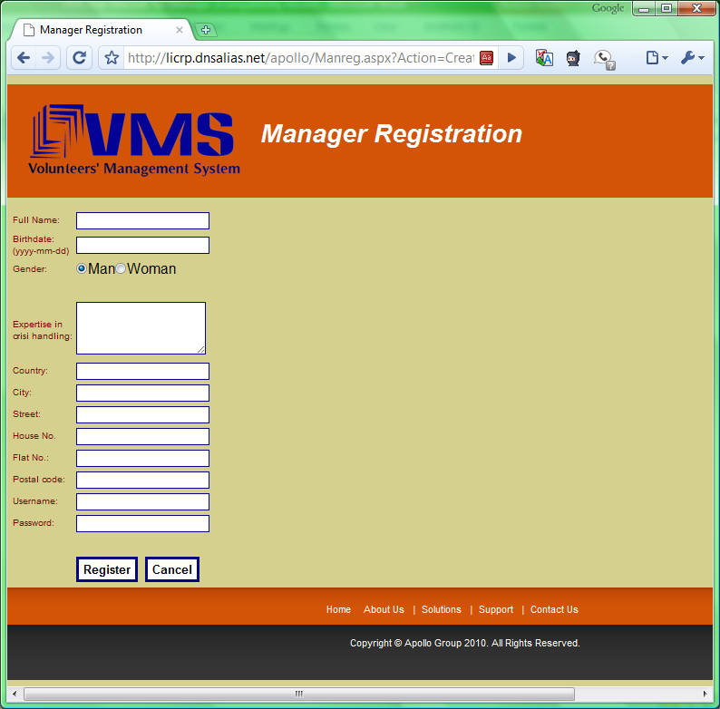
Figrure 2.1 (a)

Steps of approving or disapproving manager’s profile:
The registered manager which has not been approved can’t log in to the VMS. Before manager can log in to the VMS, he needs to be approved by the administrator user. To do so, follow these steps:
- Go to login page of the website http://licrp.dnsalias.net/apollo/login.aspx
- Enter username: Admin /password:Password
- Click Login button
- User is redirected to the list of the manager
- User can check the checkbox Approved for the managager.

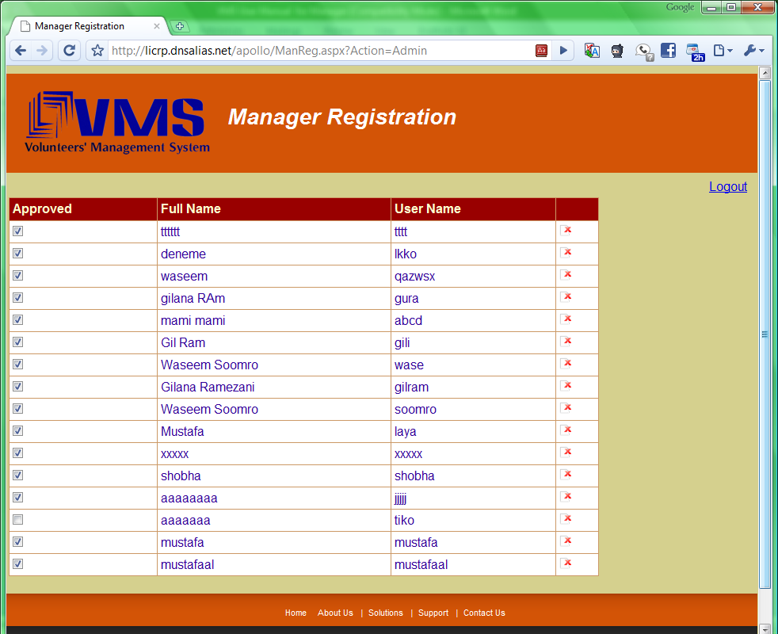
Figrure 2.1 (b)

The manager’s profile is approved. Manager can login to the VMS with his/her username and password.
If the manager’s profile is already approved but because of some reasons needs to be disapproved, in the step 5 admin user can uncheck the Approved checkbox. After that manager will not be able to loing to the VMS.

Steps of manager Log in:
The registered manager which has been approved can log in to the VMS.

- Go to login page of the website http://licrp.dnsalias.net/apollo/login.aspx
- Enter username and password
- Select Manager as user type and click Login
- You will be guided to the Crisis Board page

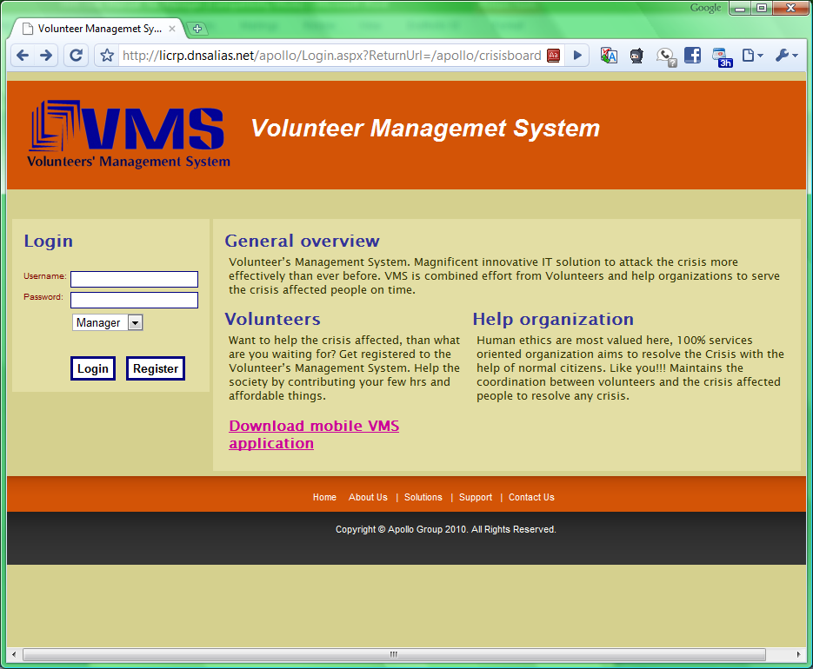
Figure 2.1 (c)

  - How to work with crisis
The manager needs to create a crisis in the system to be able to manage it.

Steps of creating crisis:
After login in to the system, user will be redirected to the Crisis Board page.
- Select Define new crisis from Crisis menu
- Enter a name for the crisis in Crisis name field
- Find the location of crisis using the search box inside the map
- Click on the map to specify the location of crisis.
- Define the area of crisis using the radius drop-down list.
- Select type of the crisis from a list
- Enter details of crisis in Explanation field
- Click Save button.

User will be redirected to the Crisis Board page.

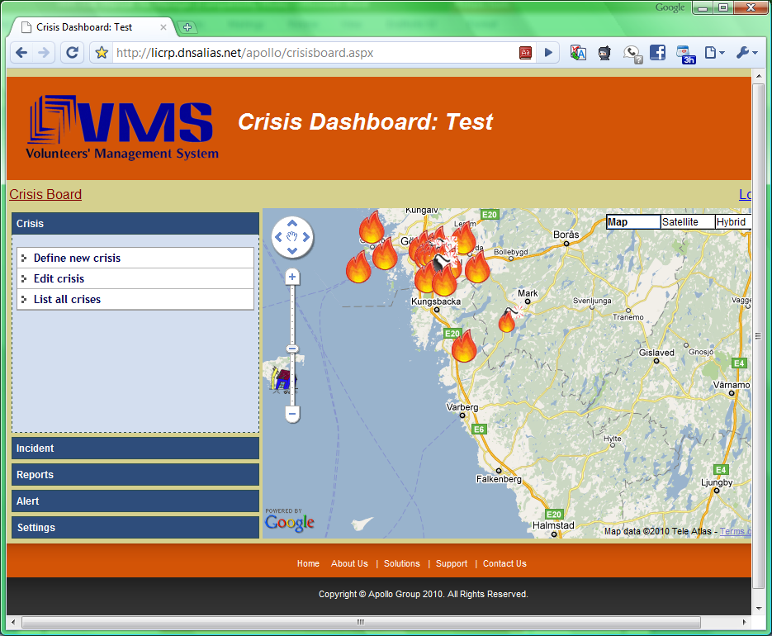
Figure 2.2

Steps of editing crisis:
During the crisis time manager can edit the information of the crisis. To do so, follow these steps.
- Select Edit crisis from the Crisis menu
- Make needed changes in the crisis information.
- Click Save button.

Steps of editing and closing crisis:
After all incidents of the crisis are closed and crisis is resolved, it can be closed in the system. To do so, follow these steps
- Select Edit crisis from the Crisis menu
- Click Close crisis button.

The crisis will be closed.

How to work with incidents
More than one incident can be raised in a crisis and each incident will need some stuff in order to be resolved. VMS will help the crisis manger in handling them according to the nature of incidents.

Steps of creating incident:
To define the incident in the VMS follow these steps.

- Click Create incident from Incident menu in Crisis Board.
- Find the location of crisis using the search box inside the map and click on the location.
- Define Short description about the incident
- Select the severity of the incident
- Enter an explanation of the incident
- Add needed item by entering type, unit of measurement and the amount needed. Press Add New button to add more items.
- Enter the location address
- Click Save button, to add incident in the system.

The incident is registered in the system. The special icon will show the location of the incident on the map in the Crisis Board.

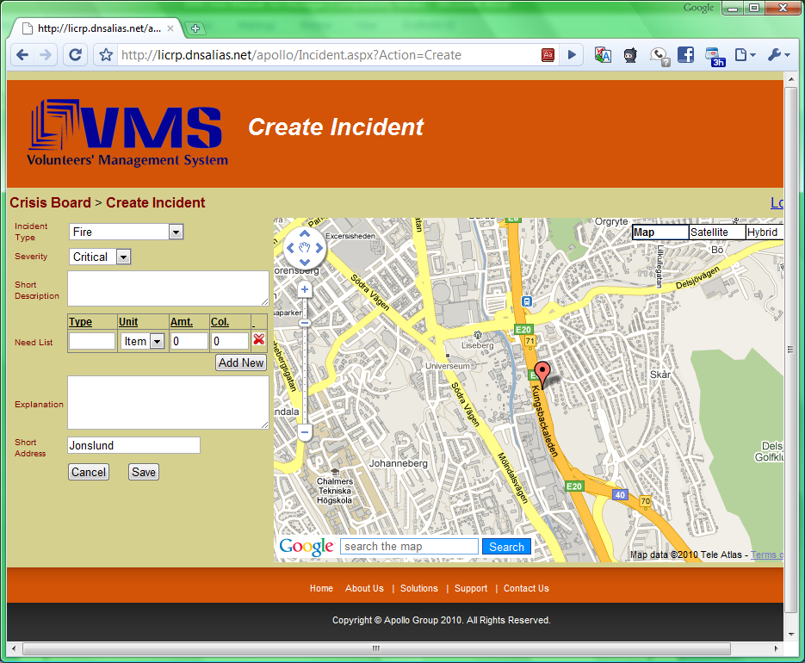
Figure 2.3 (a)

Steps of editing incident:

There are two ways to edit an incident: Select the incident on the map and click on Edit Incident link or select List all incidents and select the incident from the Incident List page. The Edit Incident page will be opened. User can change the incident information and save it by following these steps.

- Make needed changes in the incident information.
- Press Save button

The changes will be saved in the system.
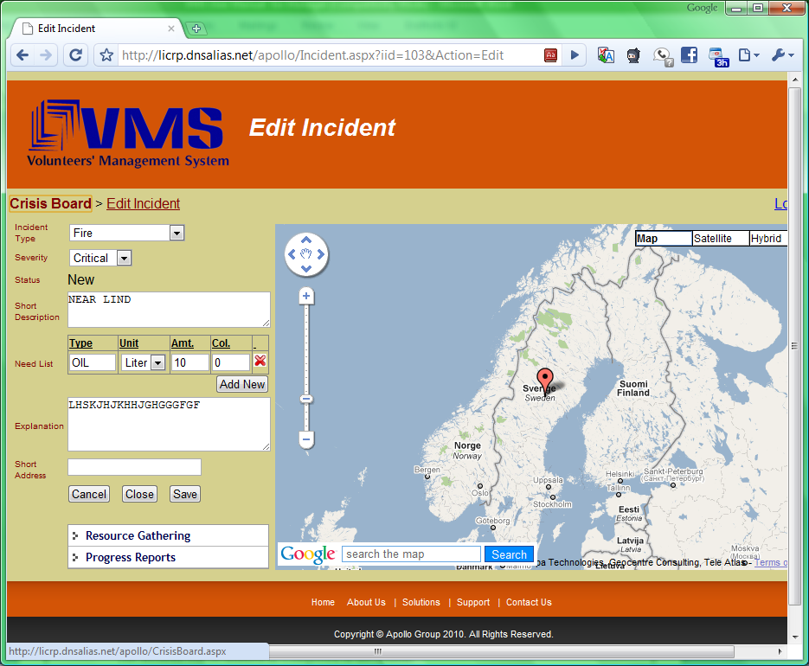
Figure 2.3 (b)

Steps of closing Incident:

After the incident is resolved and no more help from the volunteer’s is needed it can be closed. To do so, follow these steps:
- Select the incident on the map and click on Edit Incident link or select List all incidents and select the incident from the Incident List page and select the incident from the list.
- Click Close incident button.

The incident will be marked as Completed in the system.

How to work with requests
A manager can send a help request to volunteers based on the location and the type of crisis. By sending help request, manager can get the help from the volunteers for resolving the incidents.

Steps of creating request:

To create requests user need to be redirected to the incident related Resource Gathering page. From the Crisis Board user can select desired incident on the map and click on Resource Gathering link or select List all incidents the Incident menu, select the incident from the Incident List page and select Resource Gathering button. User will be redirected to the Resource Gathering page. Request can be created by following these steps:

- Click Add new request link
- Enter Request name
- Enter Request Message
- Select items which are needed to request from the volunteers
- Click Save button

System automatically sends the request to volunteers based on their location.
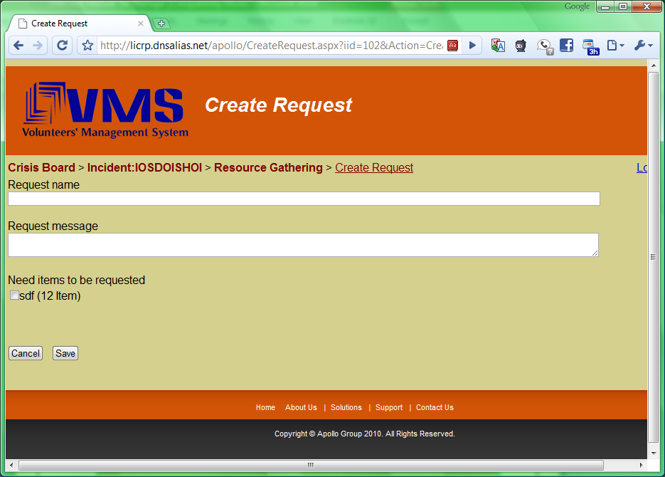
Figure 2.4 (a)

Steps of editing request:
Manager can change the request message or add or remove some of the items from the request. For that purpose user needs to be redirected to the incident related Resource Gathering page. From the Crisis Board user can select desired incident on the map and click on Resource Gathering link or select List all incidents the Incident menu, select the incident from the Incident List page and select Resource Gathering button. User will be redirected to the Resource Gathering page. Request can be created by following these steps:

- Click on the icon Active (for active requests) or Not Active (for suspended requests) . Edit Request page will be shown.
- Edit Request name
- Edit Request Message
- Change the status to Suspended, if the request needs to be suspended.
- Change the status to Active, if the request needs to be activated.
- Select items which are needed to request from the volunteers
- Click Save button
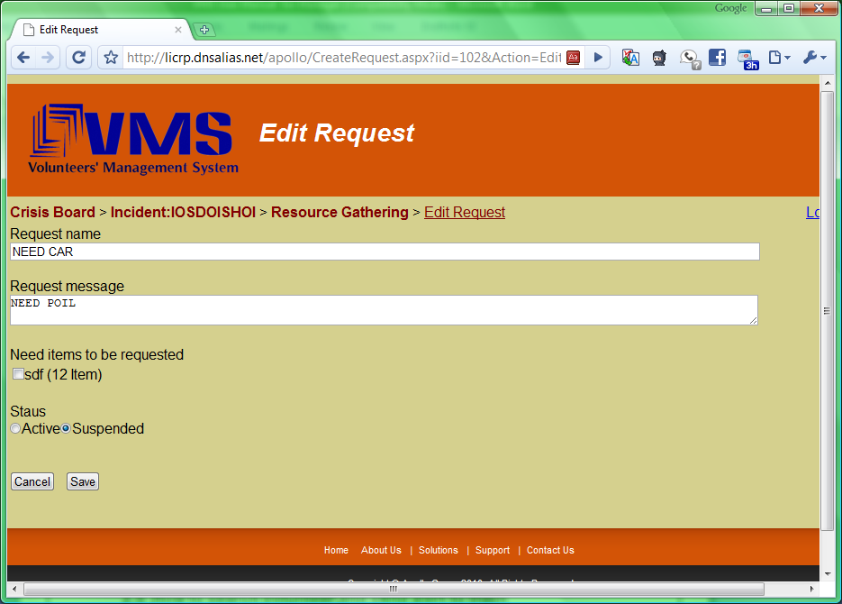
Figure 2.4 (b)

How to search volunteer and send alert to them

Steps of searching volunteer sending them alert:
VMS allow the crisis manager to search for the volunteers with the specific education or training. It helps the manager to send specific message to those volunteers. To do so, follow these steps.

- Click Send Alert from the Alert menu. User will be redirected to Create New Alert page
- Enter keywords separating them by space in Words in profile textbox for searching the specific volunteers and press Search button
- Select the volunteers from the list
- Enter the message in Alert Message textbox
- Press Send button

System sends the message to the selected volunteers.

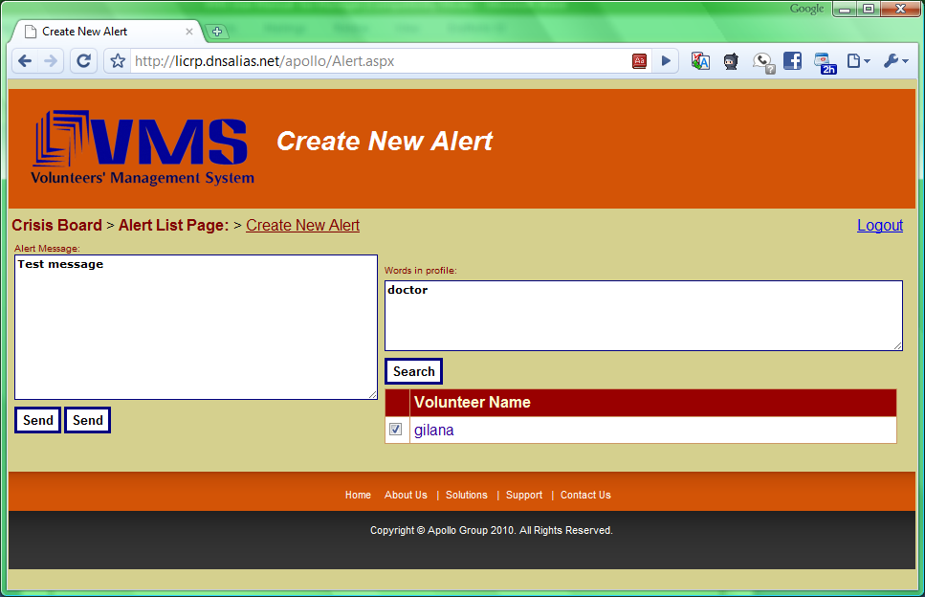
Figure 2.5

Revision History
Note: this part is only for lecturer and should be removed in deployment package.

Name | Date | Description | Version
Waseem Soomro | 25 Apr 10 | Created a User-Manual with initial outline | 0.1
Waseem Soomro | 03 May 10 | Revised Introduction and How To sections | 0.2
Waseem Soomro | 04 May 10 | Revised Glossary, How To sections | 2.0
Gilana Ramezani,  Mustafa Al-Zubaidi | 05 May 10 | Reviewed | 2.1
Waseem Soomro | 05 May 10 | Added About VMS part, added screenshots, and fixed defects | 2.1
Team | 05 May 10 | Shared to the peer group (Evolution) for review | 2.2
Waseem Soomro | 06 May 10 | Changes made after peer-review-comments | 3.0
Gilana Ramezani | 11 May 10 | Edit and Revise Introduction section, steps 3.3, 3.4 and 3.5. | 3.1
Mustafa Al-Zubaidi | 11 May 10 | Edit and Revise section 2 (about VMS), steps 3.1and 3.2. | 3.1
Mustafa Al-Zubaidi  Gilana Ramezani  Waseem Soomro | 15 May 10 | Reviewed whole the document and fixed it. | 3.1
Abdollah Tabareh  Abdullah Arslan | 19 May10 | Fixed all sections. | 3.2
Waseem Soomro | 19 May10 | Updated Screen shots | 3.3

